There is extra care required when dealing with an outdoor job to ensure the project goes smoothly.
Listed below are things to take into consideration.

Material
Not all materials are recommended for outdoor use, the materials we should be recommending is:
- Natural stone
- Durable Porcelain (Dekton)
Quartz, while it has some outdoor use to be considered, has more considerations than the prior listed. Therefore, it should only be recommended under specific circumstances.
The most robust applications have the least amount of adhesive required. Reducing Mitres and Laminations is preferred. A waterproof, breathable cover is recommended.
Clearances for outdoor applications are often larger to allow for material expansion and contraction due to temperature.

Structure
There have been issues regarding communication with customers about the structural base of outdoor fireplaces and kitchens. Here are some general notes to keep in mind.
- Follow structural Parameters of a normal kitchen
- Gap filling beyond a bead of silicon caulking below the countertop is the responsibility of the customer
- Nothing can be obstructing the area where the countertop will be placed
- requirements for templating are the same as any other kitchen…appliances/sinks etc. onsite

For Dekton/ Porcelain Specifically
- The back of the top must be fully supported with cement board between the structure and the top.
- Plywood is NOT acceptable support; due to outdoor conditions the plywood can warp and cause the porcelain to crack.

Below Photos include ready to install : level, minimum gap, cement board, no obstruction:
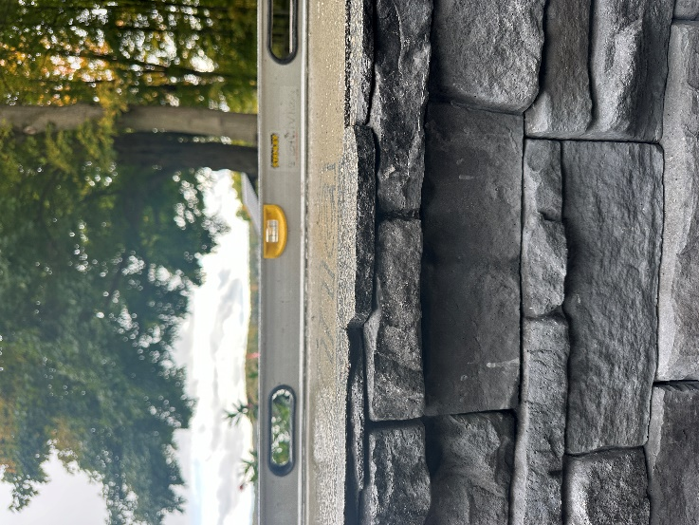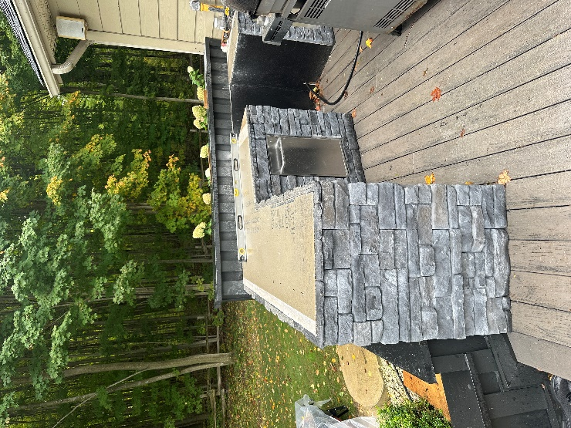
Photo below is NOT ready to install: not level, sill clips obstructing, plywood, potential substantial gap.
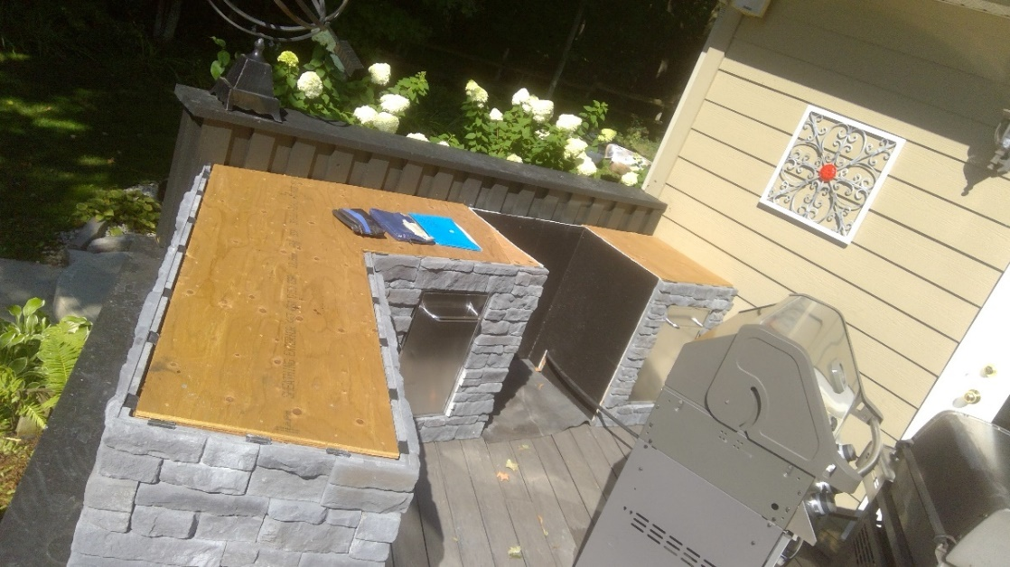

REVISION LOG
Revision # | Date | Changes | Author, Job Title
REV 0. | 2025-03-25 | SOP CREATED | Ashley Pilkington, Showroom/Purchasing
REV 1. | 2025-07-22 | FORMATTING UPDATE | Ashley Pilkington, Showroom/Purchasing

TRAINING LOG
Date Trained | Name, Job Title
2025-07-22 | Ashley Pilkington, Showroom/Purchasing

